

Network Administration
Assessment S1: Network Design Task
Module Coordinator: Ian Wills
Marker: Ian Wills

Date of submission: 29/05/2024
Number of words: 2004

Executive Summary:
This report talks about the plan for a new network for TerraGaff Ltd, a medium-sized company moving to a new office in Ulverston, Cumbria (UK). TerraGaff Ltd. will use three floors of a building and each floor needs its part of the network. The report looks at three different network plans: a hierarchical network, a VLAN network, and a fully cloud-based network using Azure. After some consideration, the VLAN network is suggested to be the one that is used because it can grow easily, is cheap, has good security, and is simple to manage. The report gives a careful plan for the suggested choice, like IP address plans, tools needed, server needs, and cost look.

Introduction:
TerraGaff Ltd. needs a strong, safe, and flexible network for its new three-floor office. This network must work for the company's office, employees, and clients, with both wired and wireless connections. The goal is to make sure the network works well, is always available, and keeps company data safe while helping the business run smoothly.

Requirements Analysis:
Company Network Requirements:
- TerraGaff Ltd. needs these requirements for its network:
- Fast Internet: Reliable high-speed internet provided by EE, a local ISP.
- Wired and Wireless: Separate wired and wireless networks for different floors.
- Different Networks: Separate subnets for each floor for better security and management.
- WiFi Access: Two WiFi access points per floor for employees and visitors.
- Dynamic IPs: DHCP setup for dynamic IP addresses.
- Server Hosting: In-house server for the company's website and email.
- Scalable: Ability to grow the network as the company grows.

Additional Requirements:
For a safe and good network, we need the next things:
CyberSec requirements:
- Firewall or VPN or both: To stop bad network traffic coming in and keep it safe.
- Network Segmentation: Split the network into different parts to isolate different user groups and increase the network security.
- Network-based Intrusion Detection Prevention System (NIPS/IDPS): This should be implemented to monitor all the TerraGaffs network traffic and prevent unauthorized access. (Red Hat, 2023)
- Weekly Security Updates: This will ensure that the network infrastructure is up to date and will be protected against previous vulnerabilities.
- WiFi Protected Access (WPA & WPA2): This uses wireless encryption which secures the WiFi network with an authentication protocol, requiring a password or network key when a device or user attempts to connect to the wireless network. (Sony, 2022)
Reasons for why security measures are important:
Data Protection Act: Protecting sensitive data from cyber threat actors from “applying strong data protection measures and safeguards not only protects individuals' or customer's data, but also your organization's data. Therefore, avoiding considerable problems, which may damage your reputation or your organization's confidential information.” (EDPB, 2024)
General Data Protection Regulations (GDPR) compliance must be upheld because it is an “EU law with mandatory rules for how organizations and companies must use personal data in an integrity-friendly way. Personal data means any information which, directly or indirectly, could identify a living person. Name, phone number, and address are schoolbook examples of personal data.” (GDPRSummary, 2024)

Network Design Options:

Option 1: Traditional Hierarchical Network
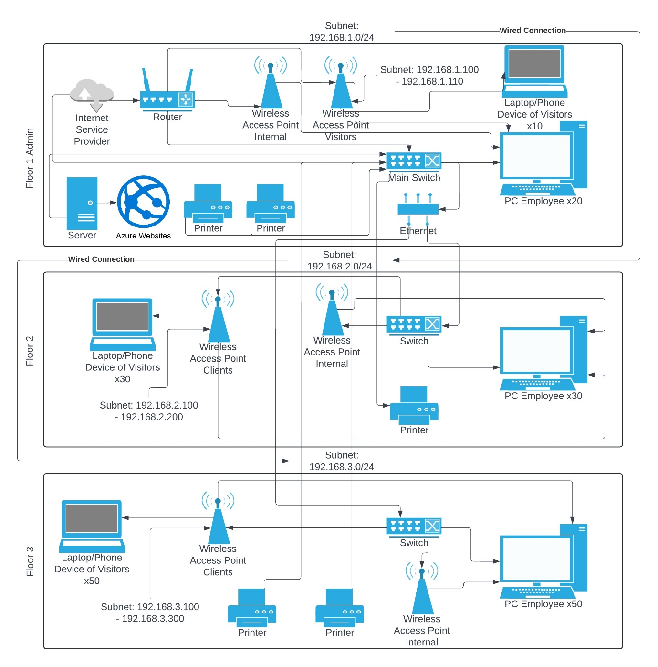
In this design 1 for TerraGaff Ltd I went with a Traditional Hierarchical network design making it fit the case study requirements. A Hierarchical network design consists of an Access Layer, Distribution Layer, and Core Layer. (Kaim, 2022)
The hierarchical network design for TerraGaff Ltd. is structured to optimize performance, scalability, and manageability while ensuring robust security and efficient resource allocation. This design spans three floors in their new office location, each with distinct subnet configurations and tailored connectivity to meet the company’s operational requirements. (Cisco Press, 2014)
Core Layer:
The central layer of TerraGaff’s network refers to the main switch positioned on the first floor. This device is responsible for backbone connectivity linking different floors so that messages can be delivered quickly and in networks of various segments. At the same time, the device is connecting with the router offered by the ISP that serves as an access point to the worldwide web. (CISCO, 2020)
Distribution Layer:
On the distribution layer, every floor is equipped with its very own switch which links with the main switch located at the ground floor. Local traffic flows are therefore controlled by these individual switches providing an essential bridge between core and access layers, due to this configuration, it is possible to prevent traffic from passing through the core switch unnecessarily; thus, optimizing bandwidth utilization while keeping it confined within the boundaries set by different floors. (Versitron, 2024)
Access Layer:
All user devices and network peripherals are part of the access layer. Each floor is set up with the following:
Wireless Access Points (WAPs):
On each floor, there are internal WAPs for employees and visitor WAPs for visitors to handle wireless connections. The WAPs are located strategically to cater to maximum coverage and connectivity.
Wired:
Each employee is provided with a wired connection running to their desktops ensuring stable high-speed access to network resources. Wireless connections are provided on demand. Printers: The printers are located on each floor.

Floor breakdowns:
Floor 1:
Subnet: 192.168.1.0/24
Endpoints: 20 employee desktops, 10 wireless visitor devices, 2 printers, and a server hosting a website.
Network hardware: Main switch, router, internal and visitor WAPs, 2 printers, and a server.
IP range for visitors: 192.168.1.100 - 192.168.1.110
Floor 2:
Subnet: 192.168.2.0/24
Endpoints: 30 employees, 30 visitor wireless connections, and a printer.
Network hardware: Floor 2’s switch and a printer.
IP range for clients: 192.168.2.100 - 192.168.2.200
Floor 3:
Subnet: 192.168.3.0/24
Endpoints: 50 employee desktops, 50 wireless visitor devices, 2 printers.
Network hardware: Floor 3’s switch, router, internal and visitor WAPs, and two printers.
IP range for visitors: 192.168.3.100 - 192.168.3.300

Option 2: VLAN Network Design
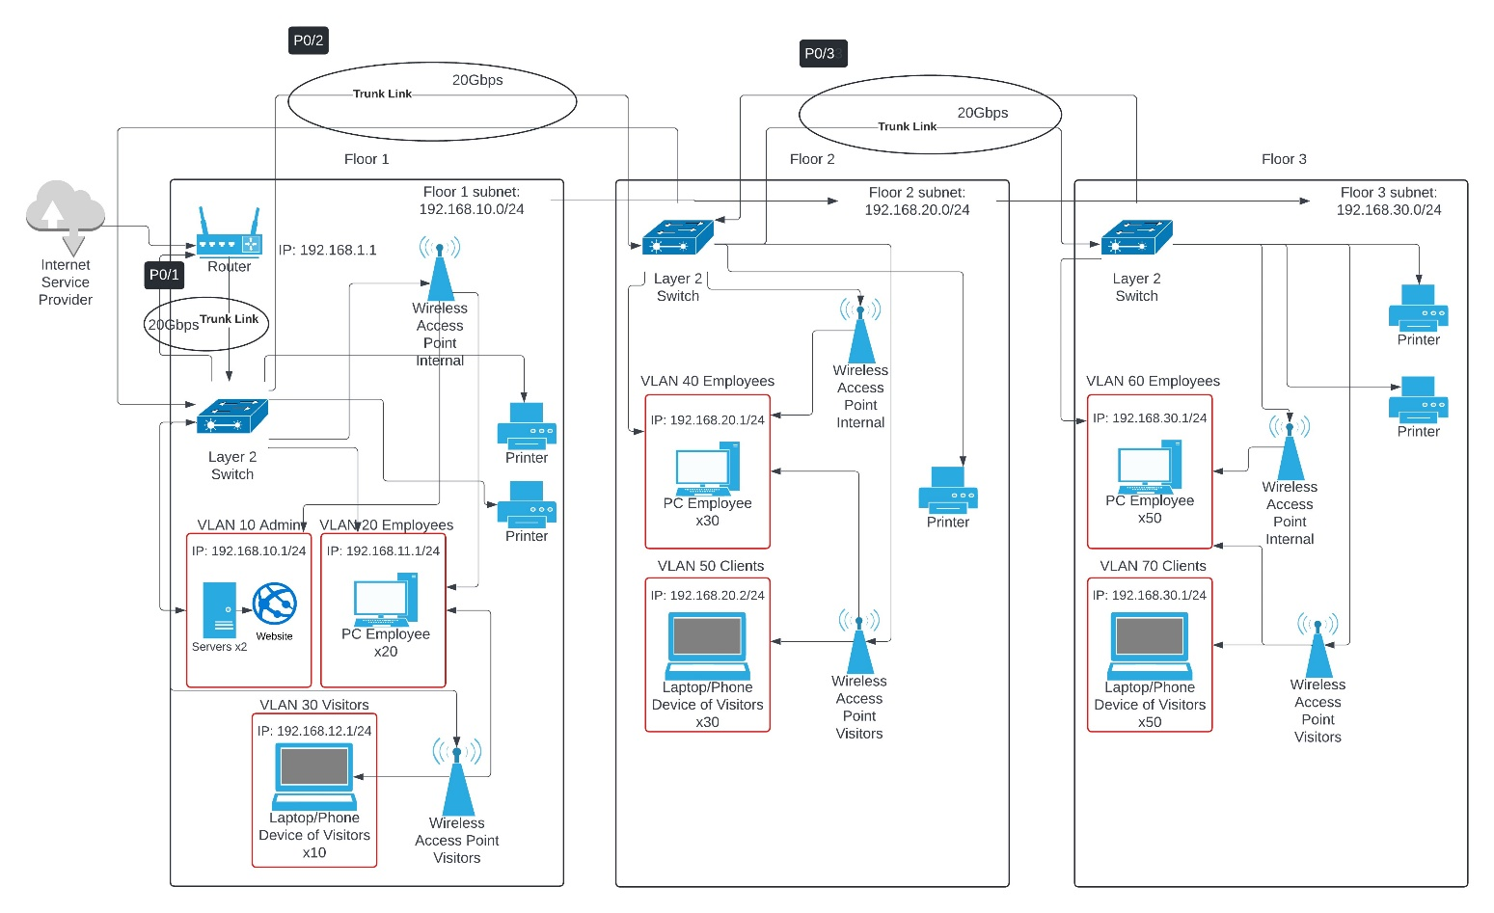
Option 2 of TerraGaff Ltd's local area network (LAN) design uses VLAN (Virtual Local Area Network) design technique to divide the system into various defined layers that are secured. This system increases safety, enables better performance of the network, and makes its administration an easy process. (GeeksforGeeks, 2018) It is designed in such a way that there are particular VLANs for various departments and groups of employees within the company building with support for each floor. (Jacobs, 2021)
General arrangement:
The plan of the VLAN networks includes vital constituents such as Layer2 switches, trunk links, and several VLANs across three floors:
Core Components: These switches are on each floor, and they are connected through trunk links of 20Gbps to ensure high data transfer rates between the floors. The network is connected to the Internet by a router that connects to an Internet Service Provider (ISP) to enable Internet access to all devices. (O'Reilly, 2024)
Trunk Links: The links that exist are labelled P0/1, P0/2, P0/3.
Subnets: Each of the floors has a subnet to manage IP addresses more efficiently.
- Floor 1: 192.168.10.0/24
- Floor 2: 192.168.20.0/24
- Floor 3: 192.168.30.0/24
Each of the floor VLANs breakdown:
Floor 1:
VLAN 10 Administrator: The VLAN is specifically designed for administrative servers and equipment, as it has an IP range of 192.168.10.1/24 to protect critical administrative functions from other kinds of traffic.
VLAN 20 Employees: it is dedicated to employee devices like PCs and shares an IP 192.168.11.1/24. This improves security and convenience in employee movement as their traffic is segmented (for quick performance access)
VLAN 30 Visitors: This has been set aside for visitors’ devices with an IP address of 192.168.12.1/24.
Floor 2:
Employees in VLAN 40: The second-floor staff equipment can use this VLAN because its IP address 192.168.20.1/24 should belong there solely.
Clients in VLAN 50: In order not to interfere with employee operations, visitor equipment is what this VLAN concerns.
Floor 3:
Employees use VLAN 60 with IP 192.168.30.1/24 on the third floor while visitors connect using VLAN 70 which is also configured with 192.168.30.1/24, but this helps to make the separation between guests and workers.

Option 3: Cloud-based Network using Azure.
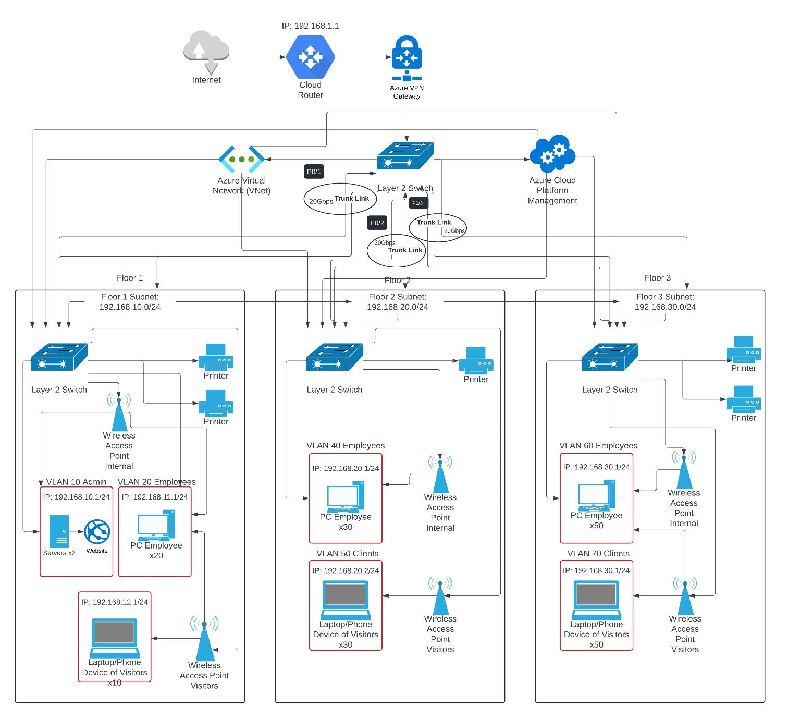
Option 3 involves Azure's cloud services are used to increase network flexibility, scalability, and security in TerraGaff Ltd.'s cloud-based network design. This design guarantees safe and effective connection between on-premises infrastructure and cloud resources by combining Azure VNet, with Azure VPN Gateway (Emerald Group, 2024)
General Arrangements:
Network using Azure Virtual Network (VNet) extends the corporate on-premises network to the cloud, thus enabling smooth communication and integration. For secure connectivity between the local network and Azure cloud services the Azure VPN Gateway is used to guarantee safe data transmission. (Microsoft, 2023) When traffic is passed from the local network to the cloud, the cloud router hands it and vice versa. Also, VPN Gateway guarantees security during information exchange or when having access at a remote location. (cherylmc, 2024)
Layer 2 Switches: The Main Layer 2 switch helps send things between groups and parts of the building. Layer 2 switches on each floor help with things in one area and join different tools, like computers, printers, and ways to get online. (communications @manageengine.com, 2024)
High-speed trunk links (20 Gbps) connect the Layer 2 switches to the core Layer 3 switch to ensure quick transmission of data and good network performance across the infrastructure. (GeeksforGeeks, 2018a)
Each floor VLAN breakdown: This is the same as the previous designs' VLAN configuration.
Both the VLAN and cloud-based networks are based on Router-on-a-stick which involves linking a single router to a switch by connecting a physical interface with different sub-interfaces for each VLAN. Benefits include simplified network management, reduced hardware costs, and an efficient method for routing between different VLANs or inter-VLAN communication without using multiple physical connections. (Cisco, 2020)

Recommended Design: VLAN Network Design
VLANs (Virtual Local Area Networks) divide the network into separate units depending on departments and user categories, improving its safety, and making it faster.
VLAN network Addresses.
- Floor 1: Subnet: 192.168.10.0/24
  - VLAN 10 Administrator: 192.168.10.1/24
  - VLAN 20 Employees: 192.168.11.1/24
  - VLAN 30 Visitors: 192.168.12.1/24
- Floor 2: Subnet: 192.168.20.0/24
  - VLAN 40 Employees: 192.168.20.1/24
  - VLAN 50 Clients: 192.168.20.2/24
- Floor 3: Subnet: 192.168.30.0/24
  - VLAN 60 Employees: 192.168.30.1/24
  - VLAN 70 Clients: 192.168.30.1/24
Advantages of VLAN network design:
Better Security: The division of segments results in less broadcasting of information and fewer instances for attackers.
Better Performance: VLANs put a cap on the size of areas for broadcasting.
Easier Management: VLANs ease network management which is also made more flexible through policy enforcement.
Using VLAN Network design gives secured high-performance solutions for TerraGaff Ltd. Through logical VLAN network segmentation, this allows a security provision as well as improved performance characteristics without so much complexity in managing it. Both start-off and continuous operation costs are not too high; as such the design is both cheap and flexible.

Cost Analysis of Recommended Design:
Network hardware:
Layer 2 Switches with VLAN support: Cisco Catalyst C9200CX-8P-2X2G-E network switch Managed L2/L3 Gigabit. £940.70 each x 3 = £2,822.10
Router: Cisco C1111-4P Ethernet Router. £797.40
Wireless Access Points: Cisco Meraki MR28 Indoor WiFi 6 Access Point: £170 x 6 = £1,020
Printers: Epson WorkForce WF-4830 All-in-One Wireless Colour Printer: £164.64 x 5 = £822.20
Ethernet Cables:
Floor 1: Employees = 20, Visitors = 10, Printers = 2, WAPs = 2, Servers = 2, Router and Switch: Added together equals 36. 36 x £100 = £3,600
Floor 2: Employees = 30, Clients = 30, Printer, WAPs = 2, Switch:
Added together equals 64. 64 x £100 = £6,400
Floor 3: Employees = 50, Clients = 50, Printers = 2, WAPs = 2, Switch:
Added together equals 105. 105 x £100 = £10,500
Maintenance: Annual Maintenance should cost around £2000
Total Cost: £27,961.70

Conclusion:
I suggested using VLAN in Terragaff Ltd. This design is preferable because it offers more security, performance, and manageability. With this design, we can divide the network into smaller portions thus decreasing broadcast domains leading to a better working system as a whole. In terms of money put into use for its operation (which includes implementation as well as maintenance), its detailed costing parameters have not gone beyond acceptable limits; comparatively speaking no other option is cheaper than it would have been there! Using VLAN for the network design, TerraGaff Ltd. will achieve a network infrastructure that enables optimization of performance, scalability, and security this gives an assurance of continuity in business processes and possible expansion of businesses in their new office.

References:
cherylmc (2024). About Azure VPN Gateway. [online] learn.microsoft.com. Available at: https://learn.microsoft.com/en-us/azure/vpn-gateway/vpn-gateway-about-vpngateways [Accessed 24 May 2024].
CISCO (2020). Campus LAN and Wireless LAN Solution Design Guide. [online] Cisco. Available at: https://www.cisco.com/c/en/us/td/docs/solutions/CVD/Campus/cisco-campus-lan-wlan-design-guide.html [Accessed 24 May 2024].
Cisco (2020). Router-on-a-Stick Inter-VLAN Routing (4.2) > Inter-VLAN Routing | Cisco Press. [online] www.ciscopress.com. Available at: https://www.ciscopress.com/articles/article.asp?p=3089357&seqNum=5 [Accessed 24 May 2024].
Cisco Press (2014). Hierarchical Network Design Overview (1.1) > Cisco Networking Academy Connecting Networks Companion Guide: Hierarchical Network Design. [online] www.ciscopress.com. Available at: https://www.ciscopress.com/articles/article.asp?p=2202410&seqNum=4 [Accessed 24 May 2024].
communications @manageengine.com, M. (2024). Switch Port & IP Address Management Software by ManageEngine OpUtils. [online] ManageEngine OpUtils. Available at: https://www.manageengine.com/products/oputils/tech-topics/layer2-vs-layer3-switch.html#:~:text=Layer%202%20switches%20offer%20limited [Accessed 24 May 2024].
EDPB (2024). Data protection benefits for you | European Data Protection Board. [online] www.edpb.europa.eu. Available at: https://www.edpb.europa.eu/sme-data-protection-guide/data-protection-benefits-for-you_en#:~:text=It%20prevents%20fraud%20and%20cybercrimes [Accessed 23 May 2024].
Emerald Group (2024). Microsoft Azure. [online] Emerald Group. Available at: https://www.emerald-group.co.uk/cloud-services/microsoft-azure/ [Accessed 24 May 2024].
GDPRSummary (2024). GDPR Summary. [online] GDPR Summary. Available at: https://www.gdprsummary.com/gdpr-summary/#:~:text=What%20is%20the%20GDPR%3F [Accessed 23 May 2024].
GeeksforGeeks (2018a). Dynamic Trunking Protocol (DTP). [online] GeeksforGeeks. Available at: https://www.geeksforgeeks.org/dynamic-trunking-protocol-dtp/?ref=header_search [Accessed 24 May 2024].
GeeksforGeeks (2018b). Virtual LAN (VLAN) - GeeksforGeeks. [online] GeeksforGeeks. Available at: https://www.geeksforgeeks.org/virtual-lan-vlan/ [Accessed 24 May 2024].
Jacobs, D. (2021). How to set up a VLAN for enterprise networks. [online] SearchNetworking. Available at: https://www.techtarget.com/searchnetworking/tip/How-to-set-up-a-VLAN-for-enterprise-networks [Accessed 24 May 2024].
Kaim, O. (2022). Hierarchical Network Design. [online] GeeksforGeeks. Available at: https://www.geeksforgeeks.org/hierarchical-network-design/ [Accessed 23 May 2024].
Microsoft (2023). Azure Virtual Network. [online] learn.microsoft.com. Available at: https://learn.microsoft.com/en-us/azure/virtual-network/virtual-networks-overview [Accessed 24 May 2024].
O'Reilly (2024). 4. VLANs and Trunking - Packet Guide to Routing and Switching [Book]. [online] www.oreilly.com. Available at: https://www.oreilly.com/library/view/packet-guide-to/9781449311315/ch04.html [Accessed 24 May 2024].
Red Hat (2023). What is an intrusion detection and prevention system (IDPS)? [online] www.redhat.com. Available at: https://www.redhat.com/en/topics/security/what-is-an-IDPS#:~:text=Red%20Hat%20help%3F- [Accessed 23 May 2024].
Sony (2022). What Is Wireless Encryption and Why Is It Used? | Sony USA. [online] www.sony.com. Available at: https://www.sony.com/electronics/support/articles/00009475 [Accessed 23 May 2024].
Versitron (2024). Core Switches, Distribution Switches, and Access Switches Uses in Ethernet Networks. [online] Versitron. Available at: https://www.versitron.com/pages/understand-the-use-of-core-switches-distribution-switches-and-access-switches-in-ethernet-networks [Accessed 24 May 2024].

